**E-Commerce Application on IBM Cloud Foundry**

**Phase 5: Project Documentation & Submission**

Team Members:

1. Thangaselvi T.A
2. Swetha R
3. Udhaya Pooja R

**Objective:**

The objective of this project is to develop and deploy a fully functional e-commerce application on the IBM Cloud Foundry platform. The primary goals of this project are as follows:

1. **Create an E-commerce Platform**: Develop a robust e-commerce platform that allows customers to browse, search, and purchase products easily and securely.

2**. Seamless User Experience**: Provide a seamless and user-friendly shopping experience, optimizing both frontend and backend components for performance.

3. **Efficient Product Management**: Enable administrators to manage inventory, process orders, and monitor sales through a user-friendly admin dashboard.

4. **Scalability and Reliability**: Design the application to be scalable, ensuring it can handle increased traffic, and maintain high availability and reliability.

5. **Security and Compliance**: Implement strong security measures to protect customer data, ensure compliance with data protection regulations, and securely process payments.

6. **Optimize for IBM Cloud Foundry**: Leverage the capabilities of the IBM Cloud Foundry platform, including services and scaling features, to ensure efficient application hosting.

**Design Thinking Process:**

1. **Research and Analysis**:

Market research to identify the target audience and competitive landscape.

Customer surveys and interviews to understand their needs and pain points.

2**. Ideation and Planning**:

Brainstorming sessions to generate ideas for platform features and user interface design.

Define the user flow and navigation structure.

Create user personas to guide design decisions.

3. **Prototyping and Validation**:

-Develop wireframes and mockups for the user interface.

Create a clickable prototype for user testing.

Gather feedback from potential users and stakeholders.

4. **Development Phases**:

Frontend development using HTML, CSS, and JavaScript for the user interface.

Backend development using Node.js, Express.js, and IBM Cloud services.

Integration of payment gateways for secure transactions.

Implement user authentication and authorization mechanisms.

Develop an admin dashboard for product management and order processing.

Implement search and filtering features for products.

Integrate shipping and tracking services for order fulfillment.

Set up analytics and reporting tools.

Conduct rigorous testing, including security and performance testing.

Prepare for the platform's launch.

**Platform Layout**:

The e-commerce application's layout consists of the following key components:

1. **Homepage**:

Visually appealing landing page featuring featured products and promotions.

Navigation menus for easy access to product categories.

2**. Product Listings**:

Categorized product listings with images, descriptions, and prices.

Sorting and filtering options to help users find products efficiently.

Product details page with additional information and customer reviews.

3. **Shopping Cart**:

User-friendly shopping cart that allows users to add, remove, or modify items.

Display of the total order value and the option to proceed to checkout.

4. **Checkout Process**:

Secure checkout with user registration or guest checkout.

Integration with payment gateways for payment processing.

Collection of address and shipping details.

5. **User Accounts**:

User registration and profile management.

Order history and tracking.

Wishlist functionality.

6. **Admin Dashboard**:

Product management, including adding, editing, and removing products.

Order processing, inventory management, and user management.

Analytics and reporting tools for administrators.

**Technical Implementation Details**:

**Technical aspects of the e-commerce application:**

**Frontend**:

HTML, CSS, and JavaScript for the user interface.

React.js for building dynamic and responsive components.

State management using Redux.

Axios for API requests to the backend.

**Backend**:

Node.js and Express.js for server development.

Integration with IBM Cloud services, such as Cloudant (NoSQL database) for storing product data and customer information.

Secure user authentication and authorization using JWT (JSON Web Tokens).

Integration with third-party payment gateways for secure payment processing.

Implementing search and filtering using IBM Watson services or other suitable technologies.

Logging and monitoring with IBM Cloud services.

**Deployment**:

Hosted on IBM Cloud Foundry.

Domain name and SSL certificate for secure connections.

Continuous integration and deployment (CI/CD) pipelines for automated updates.

**Security**:

Data encryption, input validation, and protection against common web vulnerabilities (e.g., SQL injection, XSS, CSRF).

Regular security audits and penetration testing.

**Scalability**:

Design the system to handle increased traffic and load by utilizing IBM Cloud Foundry's scaling capabilities.

**Screenshots or images of the platform's user interface**

**Login Page:**

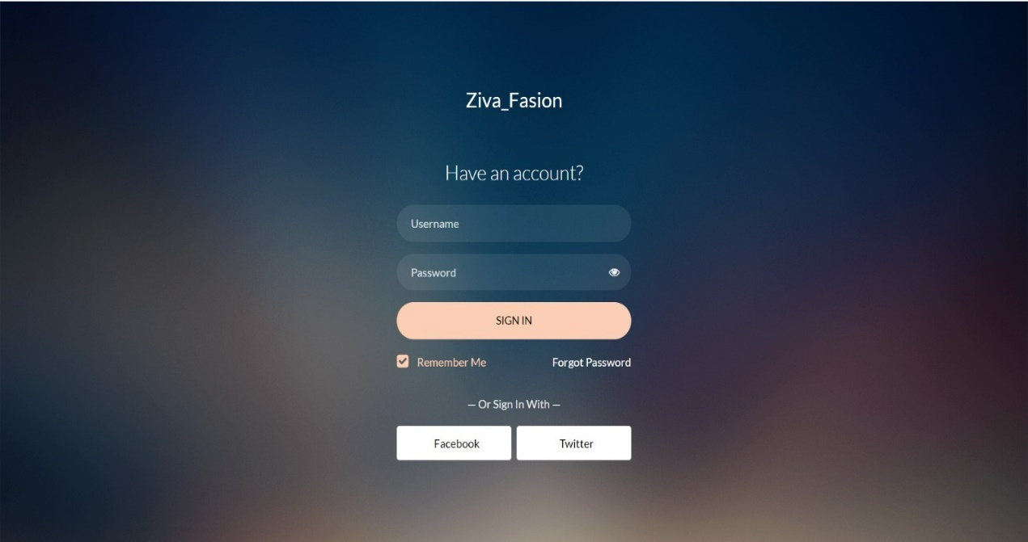

**HTML Code:**

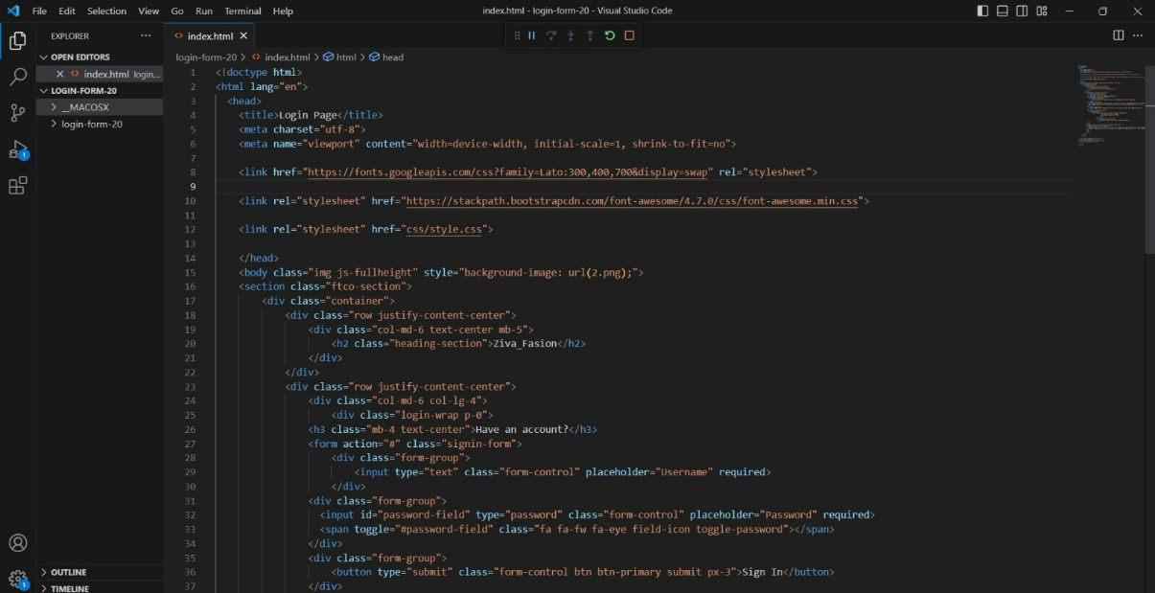

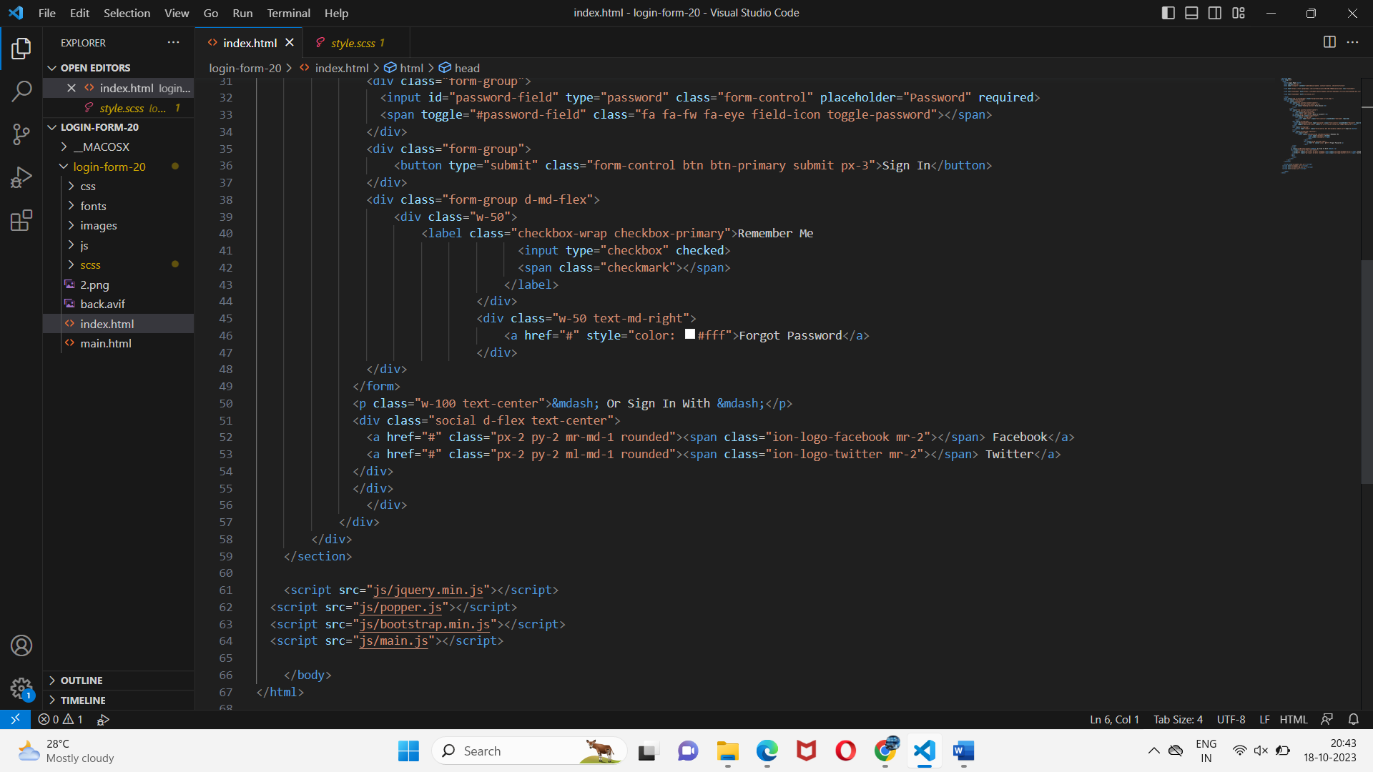

**CSS Code:**

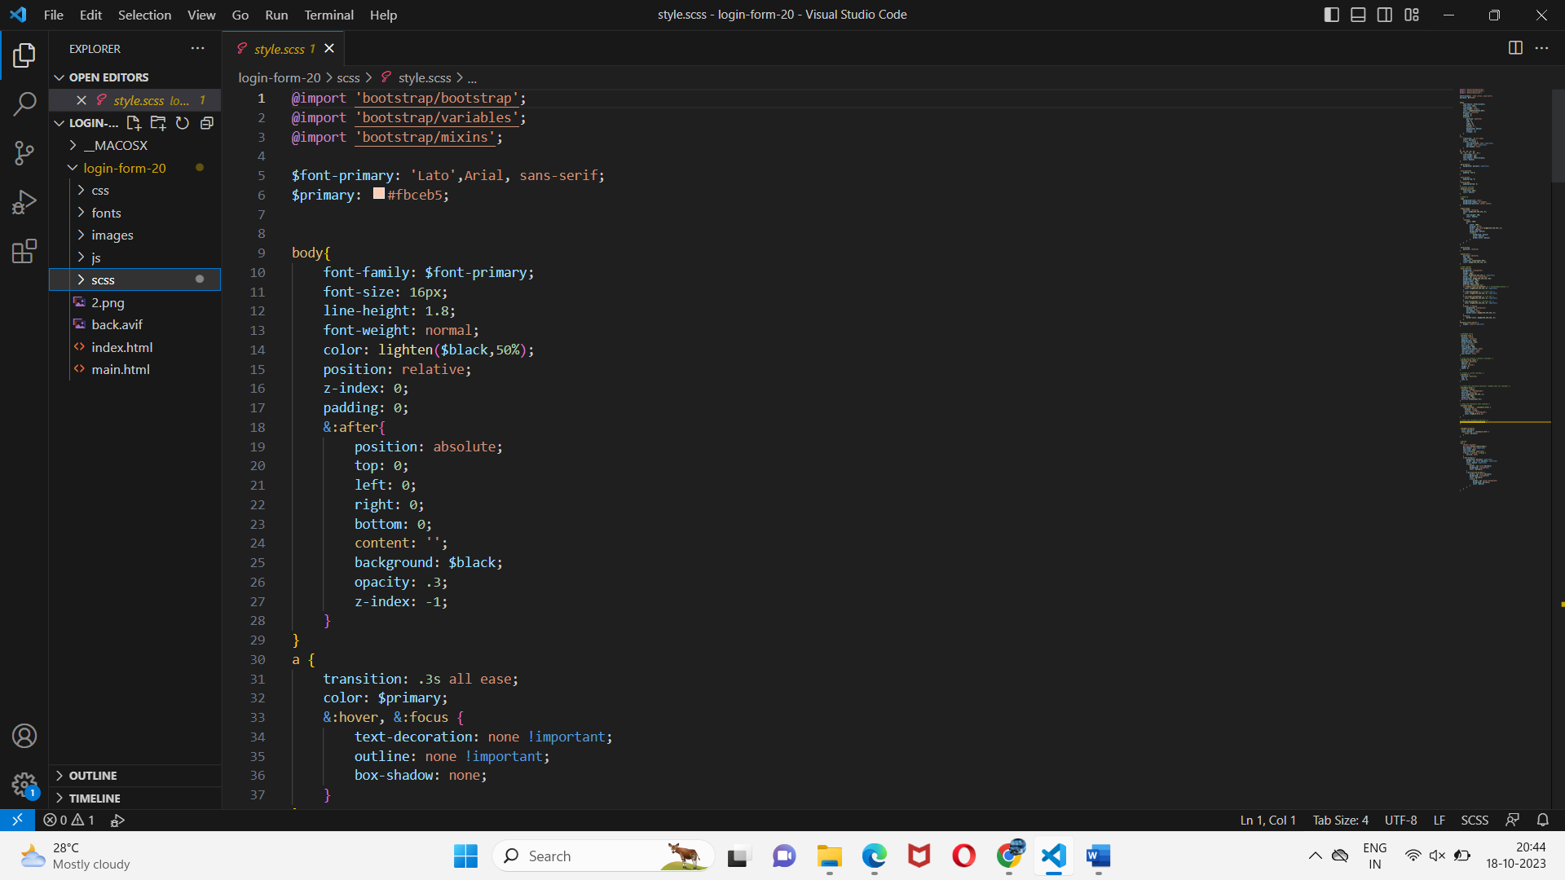

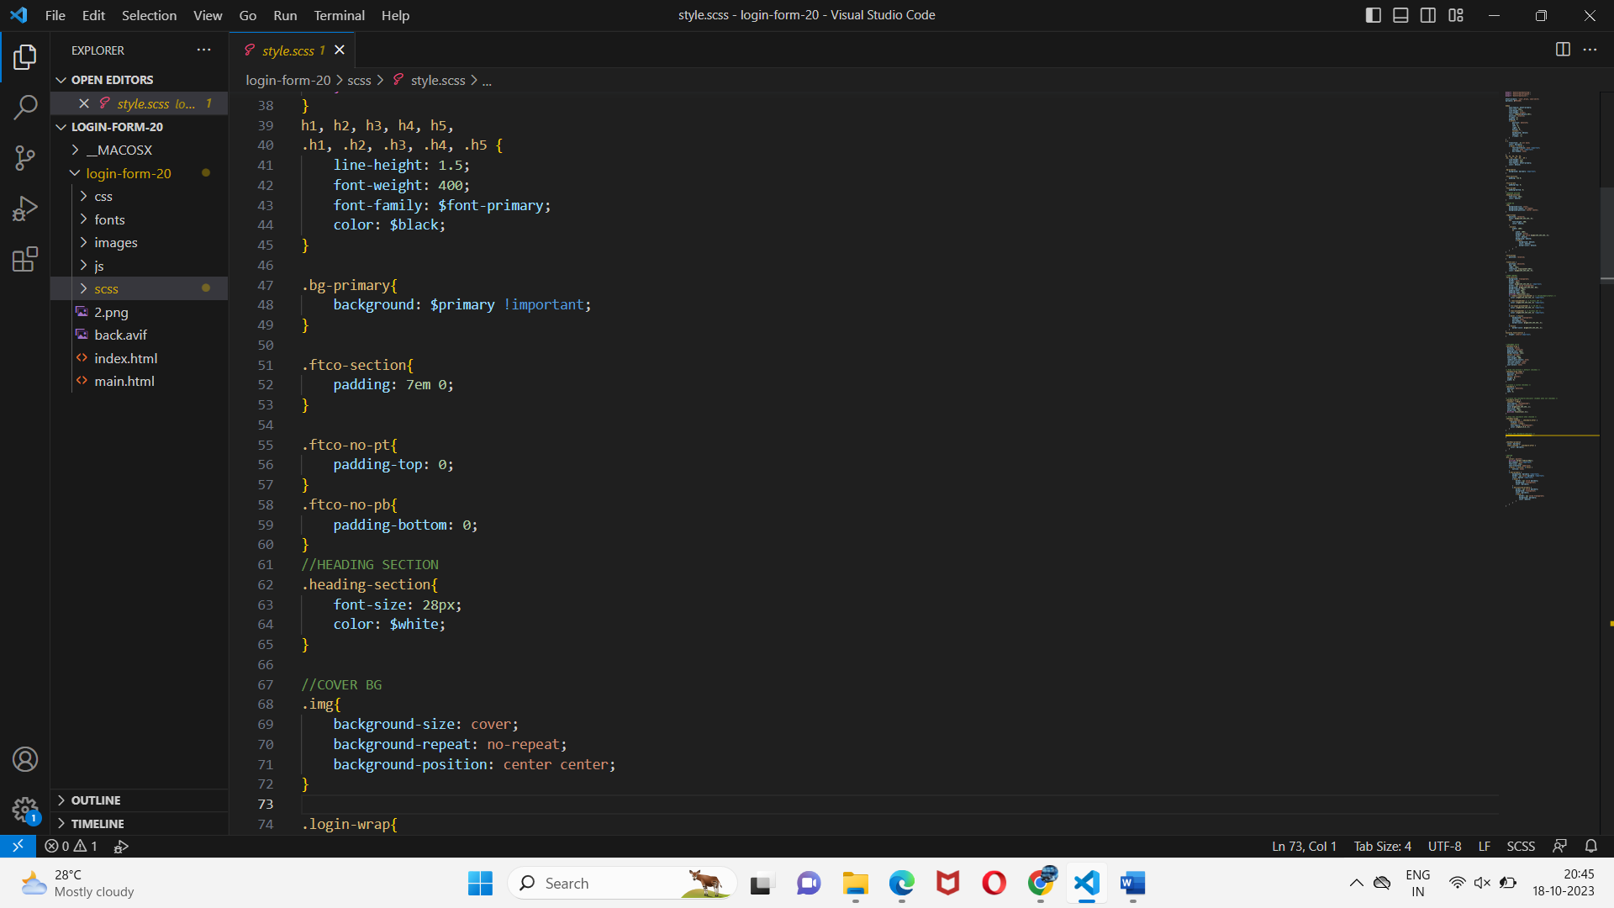

**JS Code :**

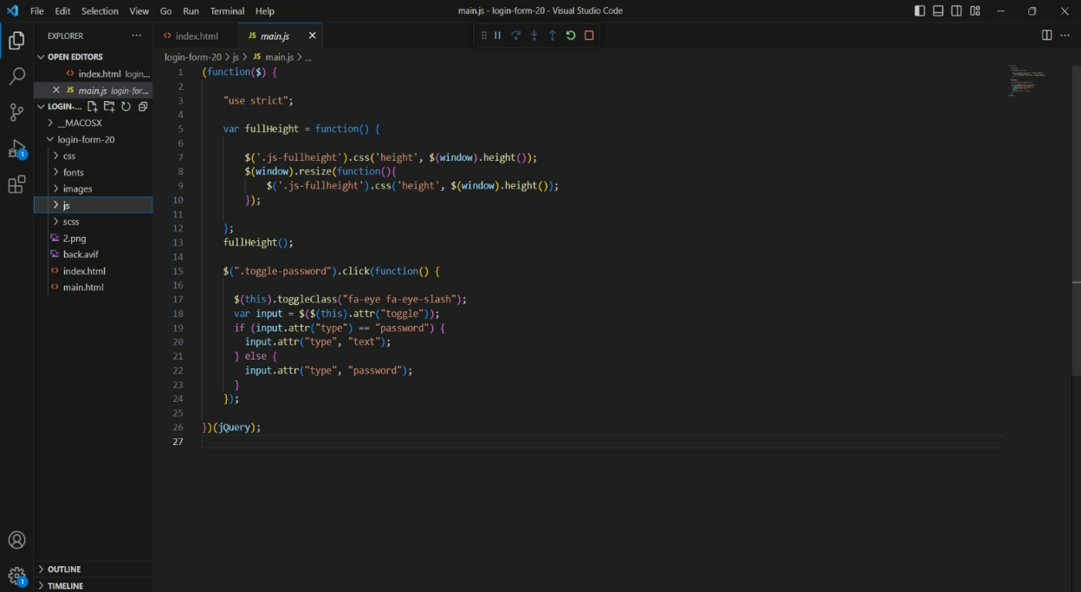

**Code For Home page:**

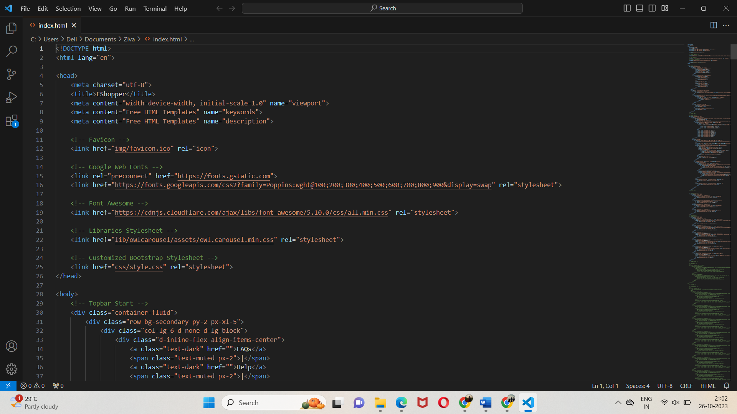

**Sample page:**

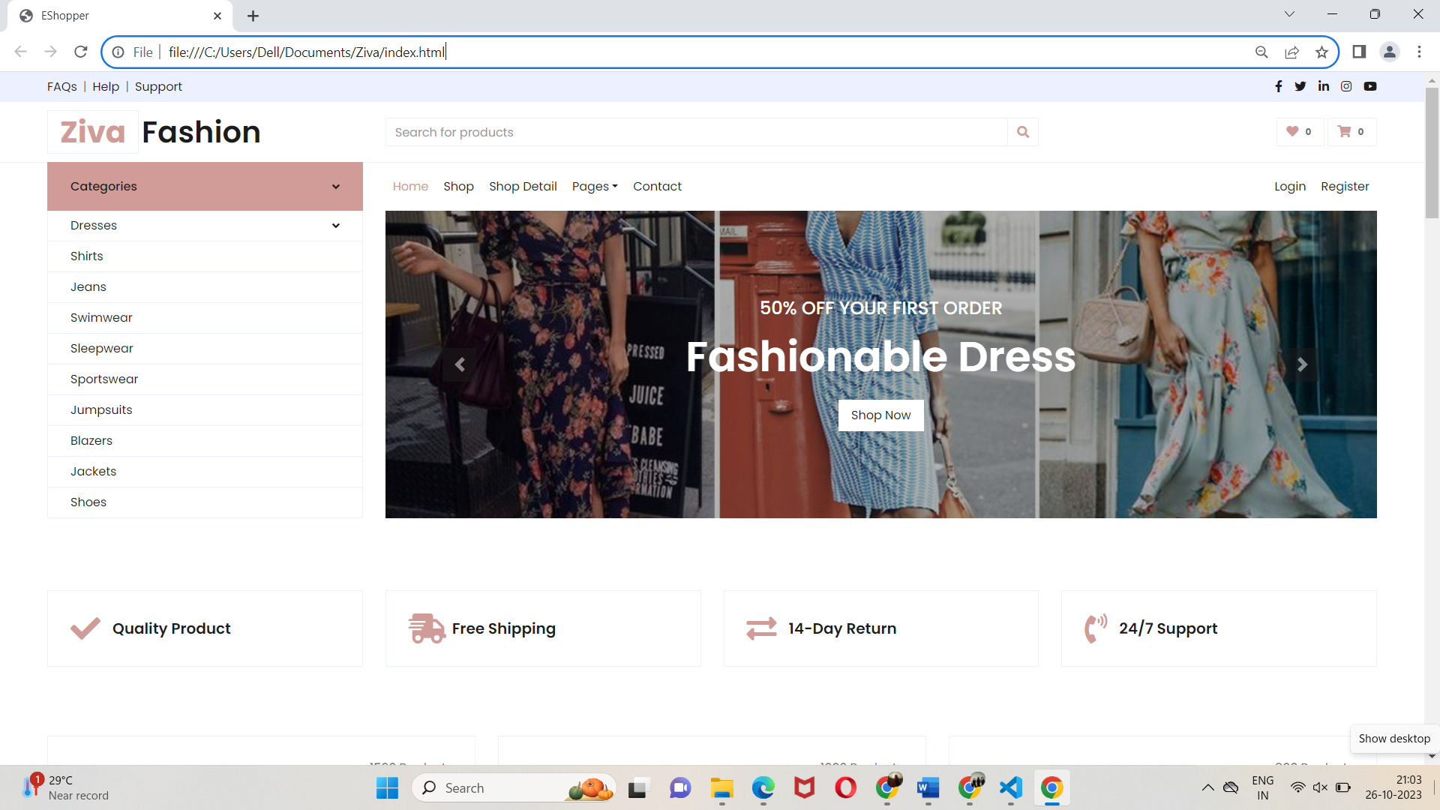

**Code for Shopping Cart Page:**

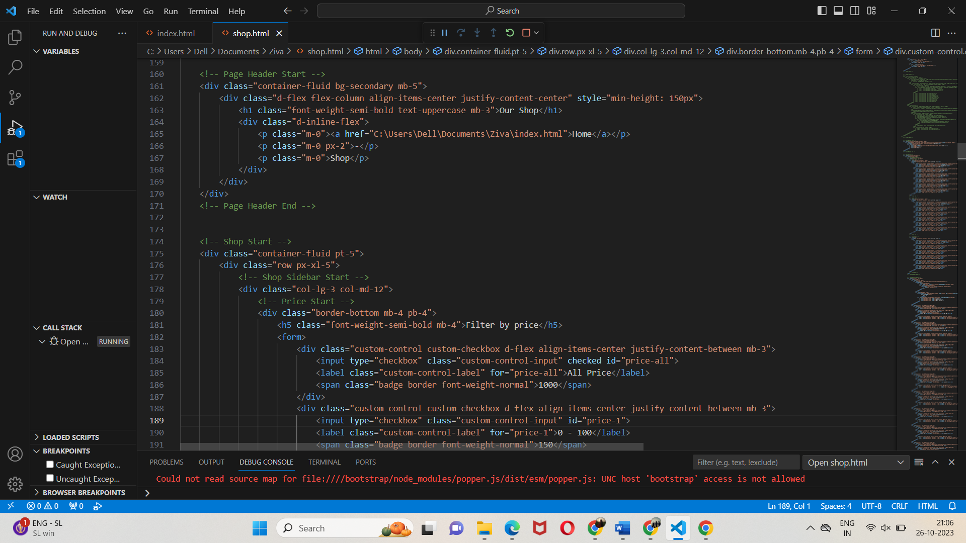

**Sample page:**

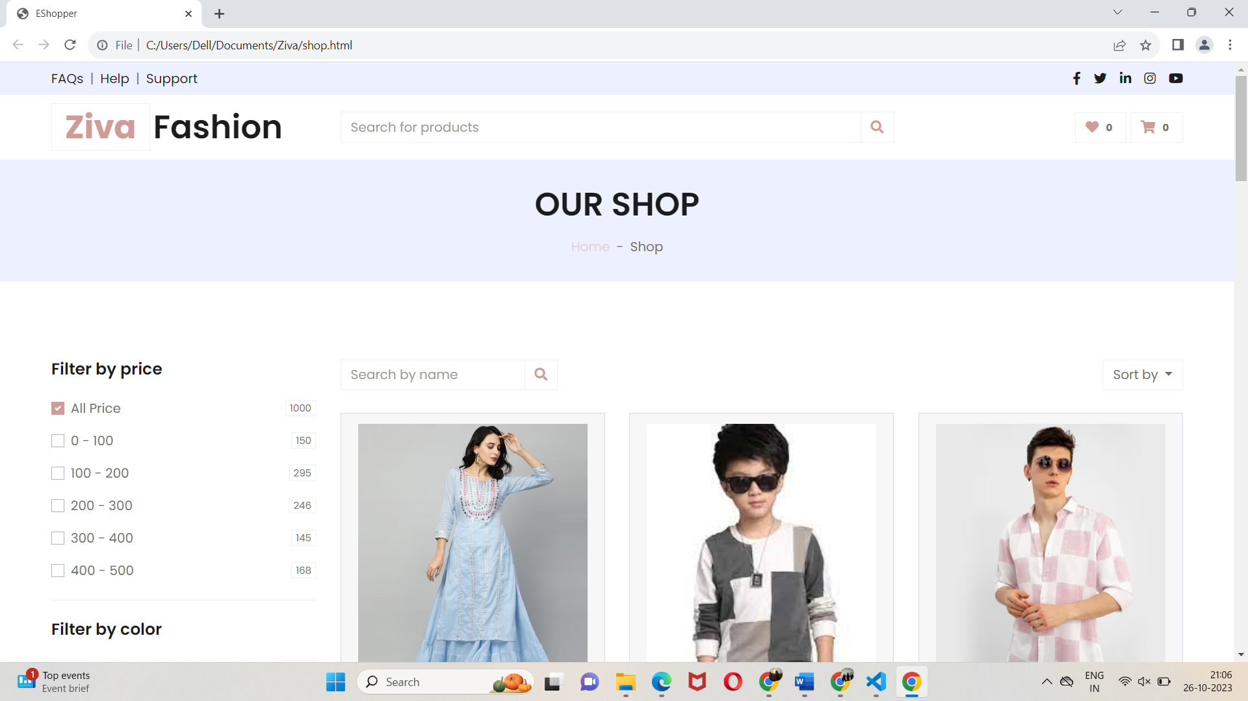

**Code for Checkout Page**:

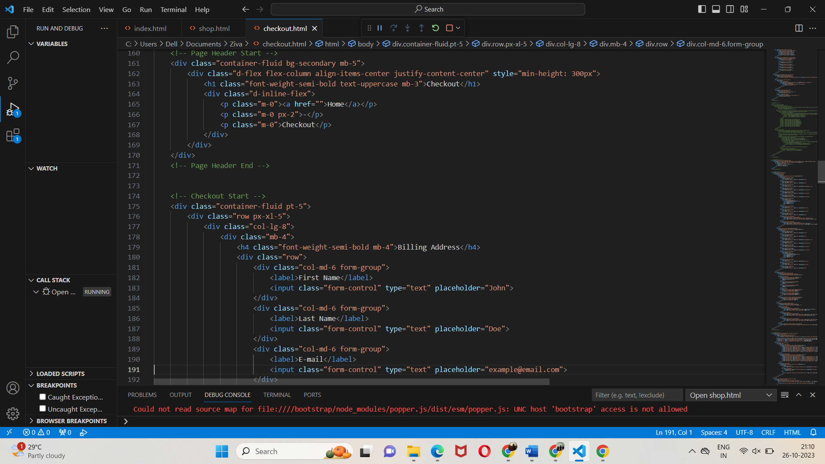

**Sample Page:**

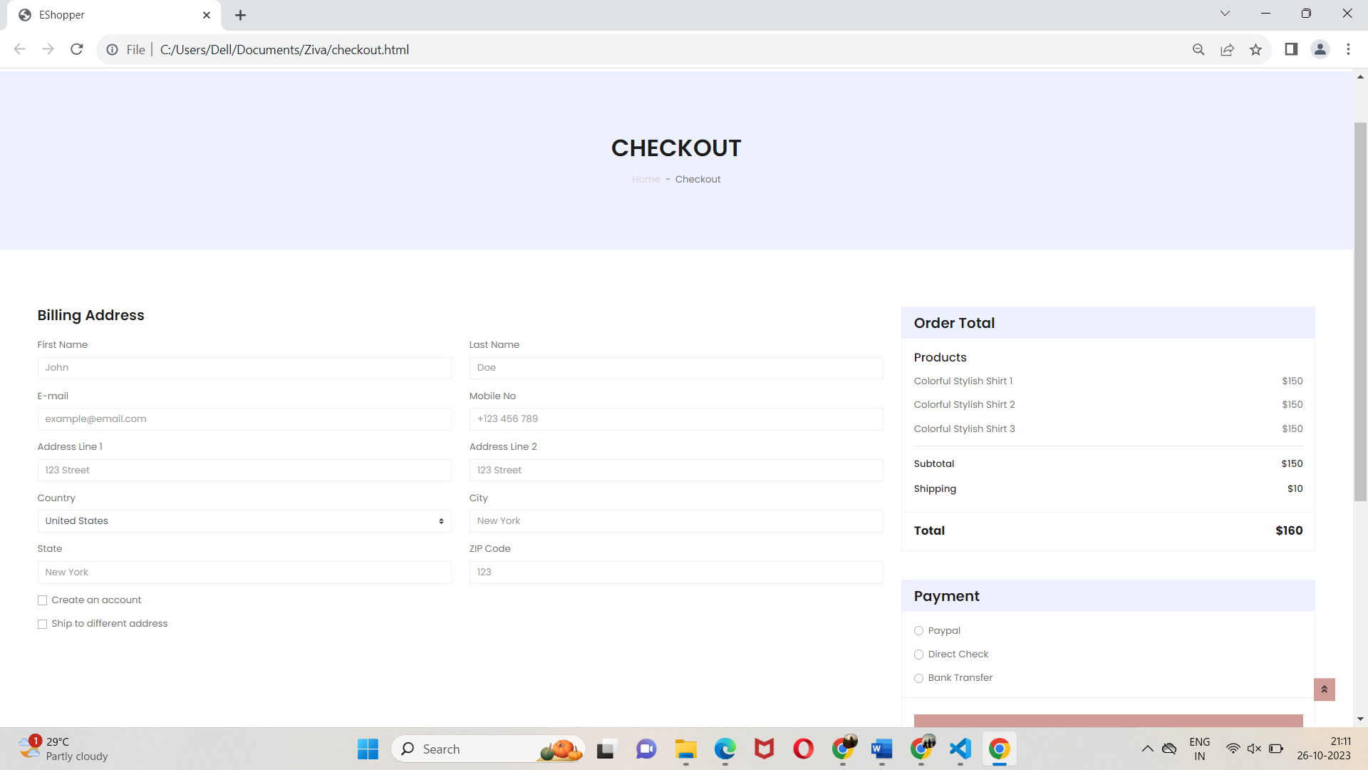

**IMPLEMENTED IN IBM CLOUD USING DB2 AND CLOUD STORAGE:**

**Step1:**

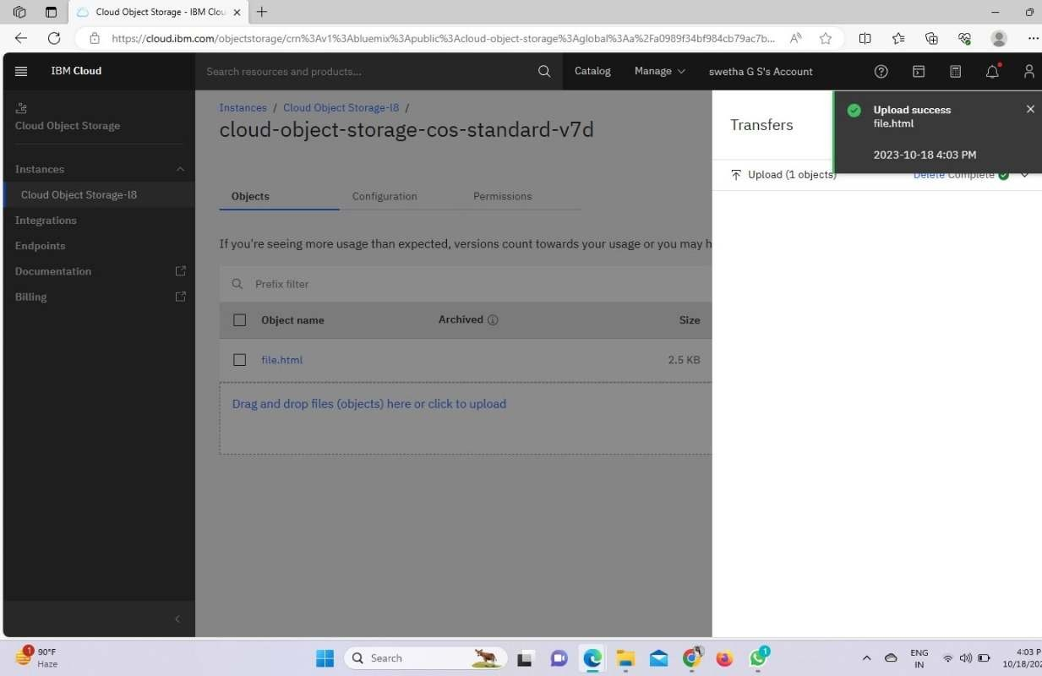

**Step 2:**

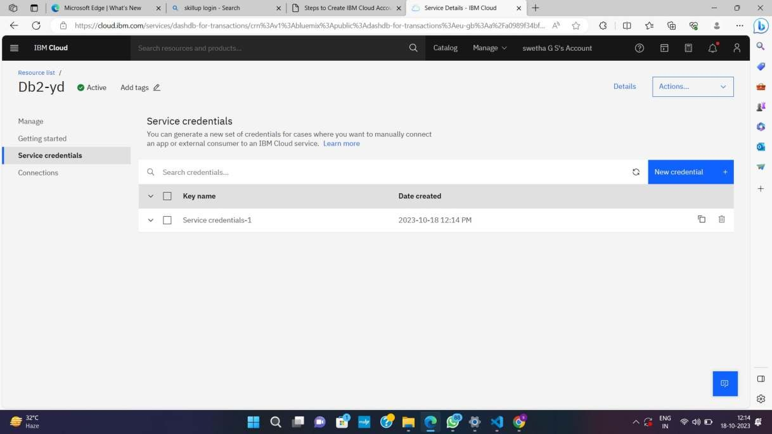

**Step 3:**

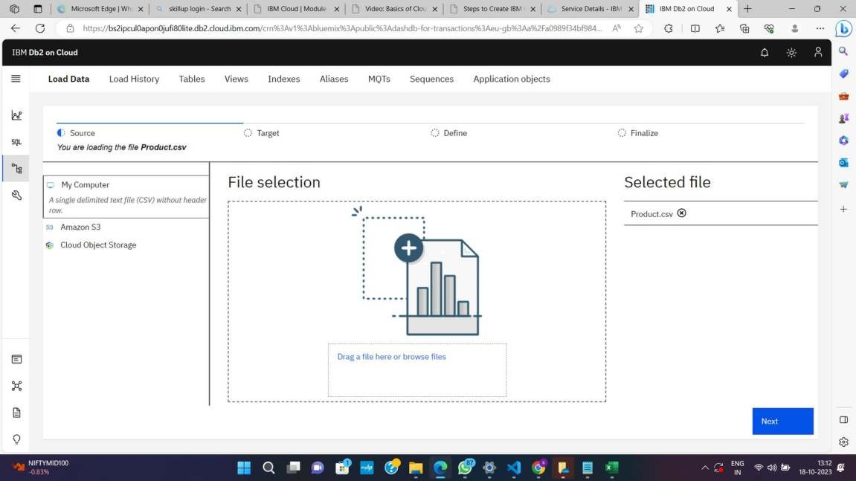

**Step 4:**

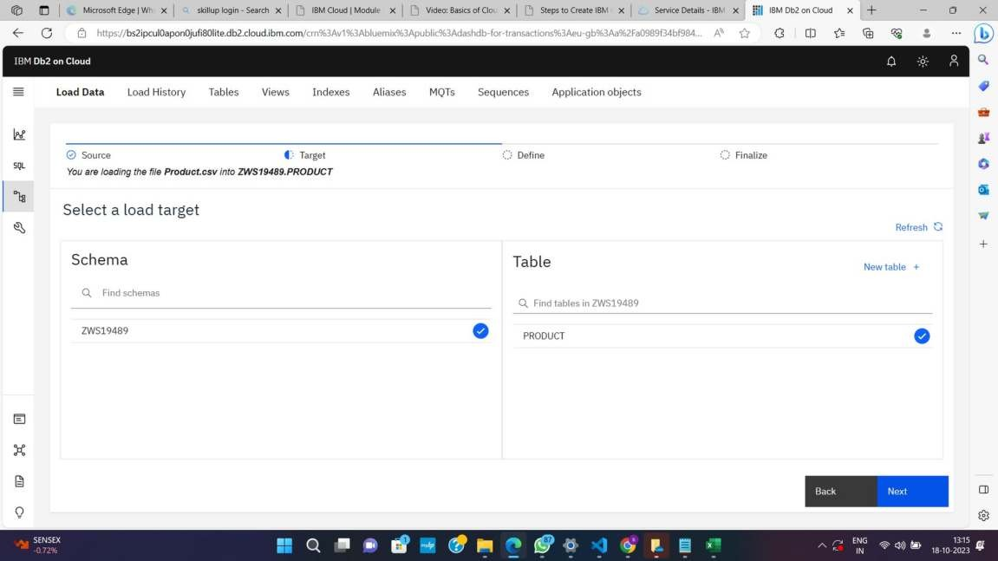

**Step 5:**

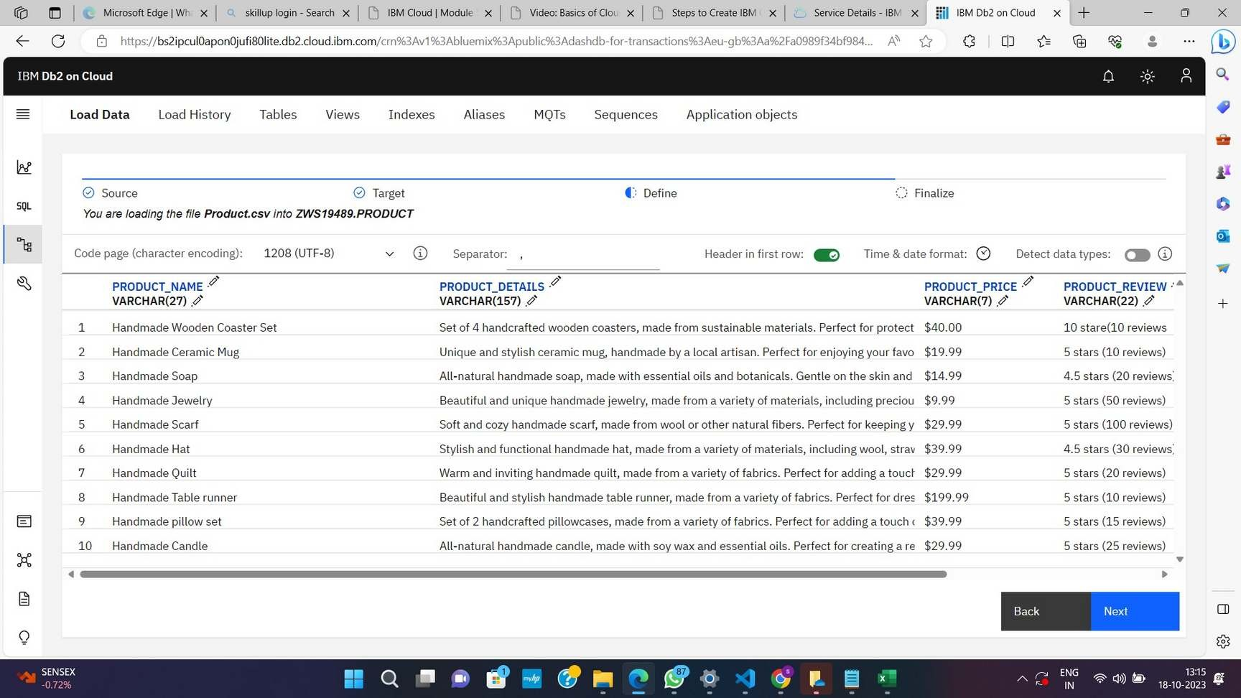

**Step 6:**

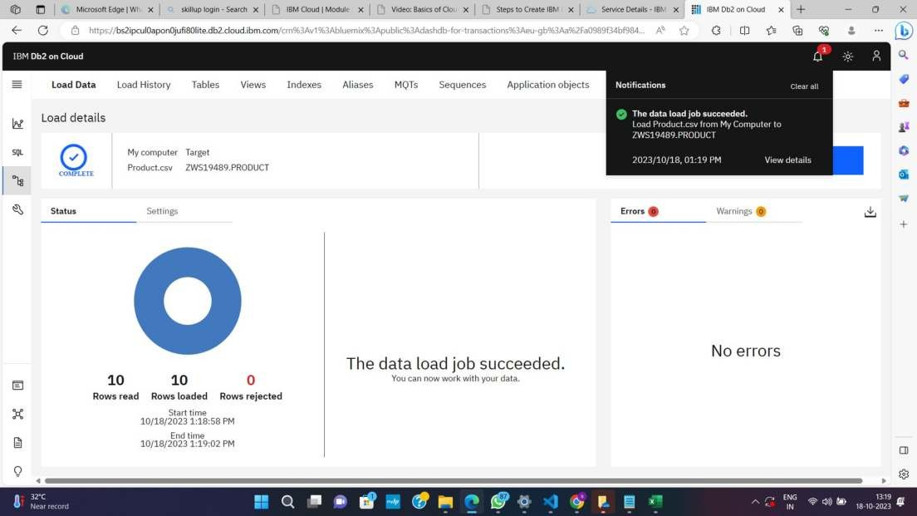

**Step 7:**

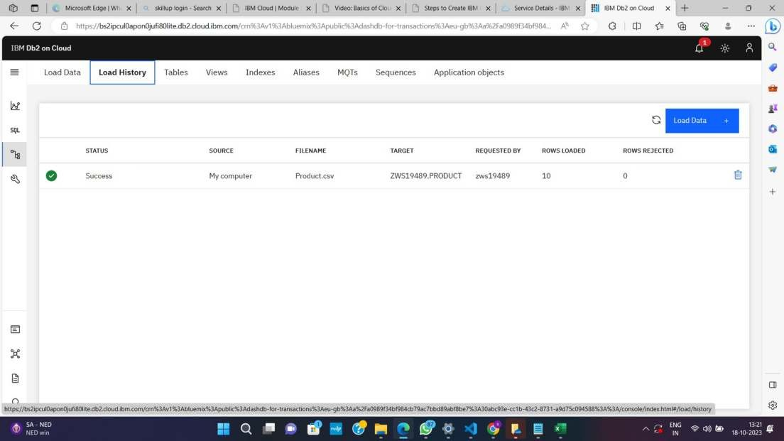

**Step 8:**

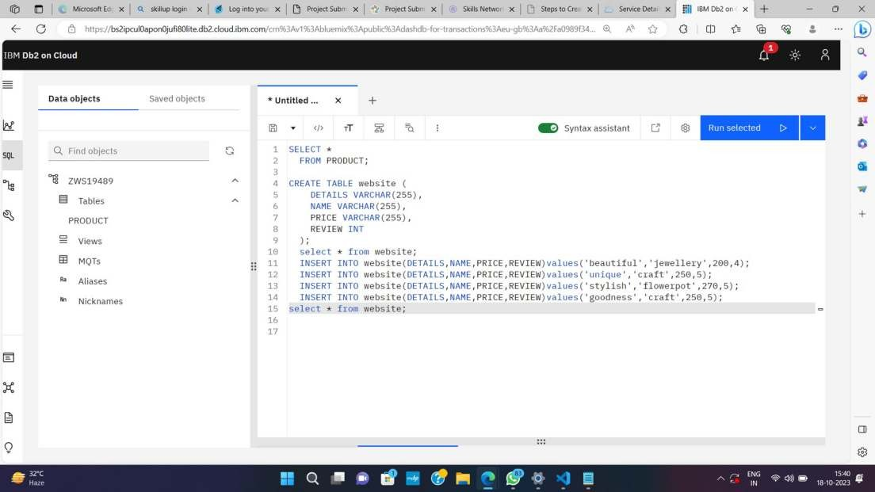

**Step 9:**

